Ethan Taylor
Supervisor: Catherine Flick
Second supervisor: Craig Weightman
Generative AI in games development
GDEV60001 Games development project

Contents
Abstract 2
Introduction 2
Aims and Objectives 3
Literature Review 4
Research Methodologies 11
Results and Findings 14
Discussion and Analysis 16
Conclusion 21
Recommendations 22
References 23
Appendices 26
Appendix 1 – Human Dialogue 26
Appendix 1 – GAI Dialogue 26
Appendix 1 – Raw Dialogue and Prompts 26

Abstract
Artificial intelligence (AI) is an industry that has seen considerable growth in the past few years with many advancements and breakthroughs. In addition to this AI capable of creating stories, images, code and even more areas have seen improvements as well. Due to this a sub-section of AI has been create called generative artificial intelligence (GAI). With this in mind many companies of various industries are trying to use AI and GAI in order to enhance their products output or the creation of such products. The games industry is no exception to this.
This paper launched an investigation into the use of GAI in the development of games. Specifically, the investigation looked at how the use of GAI to create dialogue for a village scenario would compare to a human making dialogue for the same scenario. The AI used for the dialogue was ChatGPT 5.2 as it was the latest model of an advanced text generation/chatbot AI. The investigation was to see if AI could improve development in certain areas such as quality, efficiency and cost as well as provide an output that users would appreciate.
The results of the investigation showed that GAI would greatly benefit the development process, however the game itself would be impacted by the negative opinions towards AI from the players. This aligned with this paper’s hypothesis. The results of the investigation however were not expected as they contradicted the research results in every way except for people preferring the human version over the AI version.

Introduction
Artificial intelligence (AI) is being used by all industries across the board and the rate at which businesses are picking up and using AI in different ways is increasing as well. Some sources show that in 2022 around 50% of businesses were using AI in some format. That percentage has increased to nearly 80% for 2025, this shows the importance of AI and how using it is becoming the standard in most industries (Howarth, 2025).
The games industry has used forms of AI since the start. This includes path finding algorithms, decision making systems and varying degrees of procedural content generation (PCG) among others as well. With the advancements made with generative artificial intelligence (GAI) such chatbots like ChatGPT or image generation software like Sora the games industry may be taking its next step in the field of games development. Some examples of the new wave of AI can already be seen in certain parts of the industry. A couple of years ago a mod for the game Skyrim garnered some attention for using chatbots to “bring life” to the non-player characters (NPCs) (Nexus Mods, 2023). The development team for the used GAI and PCG tools in the development process of the game. The said that the GAI was used to create the commentator voice overs using text-to-speech prompts that other large language model (LLM) based AI use (Lambe, 2025). These are some examples of how GAI is currently being used in games in order to help with the development process.

Aims and Objectives
The primary aim for this paper is to identify if using generative artificial intelligence in the process of developing dialogue for games will be a benefit to the game or if developers should continue to make dialogue through only human means. The hypothesis for this is that while using GAI will help speed up the development process while producing a product that is of higher quality than an average indie developer could produce by themselves. A secondary hypothesis is that the use of GAI will end up hindering the game in the long run because the majority of people prefer a game to be made by humans than to use GAI.
The first objective will be to design two versions of the same scenario in which the player will be able to move around a village and talk to the NPCs. The first version will have all the dialogue written by a human whereas the second version will be written by GAI.
The second objective will be to create and implement the design inside a blank Unreal Engine 5.6 world. The project will focus on the difference between human-made and artificially generated dialogue while keeping the rest the same in order for the players to give a more accurate opinion.
The final objective will be to acquire and analyse the feedback given through select feedback questions. This will then be used to either prove or disprove the hypothesis presented and to form an appropriate conclusion on the subject using the information gathered as evidence.

Literature Review
  - What is GAI
Generative artificial intelligence (GAI) is a section of artificial intelligence (AI) that focuses on the creation of human-like material (Peñalvo & Ingelmo, 1970). AI has been around “since the start of digital computation, articulated by others in Alan Turing’s seminal paper on Computing, machinery and intelligence” (Batty, 2025). GAI has been discussed by the artificial intelligent research community for years now and specifically what AI made material should be classed as GAI. The trend was for only high-quality material to be classed as GAI, however in recent years the evolution of AI through the use of publicly accessible large language models (LLMs) such as GPT 4, DALL-E 2 and copilot (Feuerriegel et al., 2023) have made higher quality material to be easier and more accessible which brought GAI into the public eye.
The current versions of GAI search for existing data on the internet to use as a base for the desired output that it has been requested to create. This means that GAI is capable of mimicking humans and their creativity by using thousands of existing examples to create something that, in effect, an amalgamation of pre-existing work that is close to what is needed to be. This is the same process used by other forms of AI such as ChatGPT, through the use of LLMs which are taught in varies ways such as supervised training which is where the model has access to the desired outputs so it knows what types of output is being asked for or reinforced learning where the model is given rewards or penalties dependant on if it fails or succeeds (Dhamani et al., 2024). Chatbots like ChatGPT use the same methods for the generation of material but differ on what problems they solve. Chatbots are designed and trained to provide human-like responses to questions while GAI refers more to the creation of poems, stories, art and code. Chatbots are still a form of GAI, however it is only a section that provides a different use case.
  - Procedural Content Generation
The games industry uses a variety of types of AI, some of the most used are pathfinding and decision-making AI. In terms of generative AI, procedural content generation (PCG) has become far more popularised and mainstream other the years. Games use PCG in different ways, some will build entire maps through mostly the use of PCG then have people go through and touch up the final details as was the case for Marvel’s Spider-Man (Jahani, 2023). PCG is a tool that generates randomized content dependant on variables and filters. An example of this would be how Tom Clansy’s Ghost Recon Wildlands used PCG to create road networks that went through and liked towns and other areas of the game (Artificial Intelligence in video games, 2025). This tool as used to save time on development as for open world games lots of manpower is required to place all the roads by hand. This meant that by using PCG the development team, Insomniac Games, could pay meet their deadlines easier.
Another benefit of PCG is the addition of contained randomness. This means that an element of unpredictability can be added into games that still aligns with the developer’s image of the project. Unpredictability solves one of the current problems with games, which is making games replayable. Some developers strive to make their games as replayable as possible in order to keep a game going for as long as possible. There have been very few games that have lasted over ten years while maintaining a high player base, some of these include World of Warcraft (Sandmann, 2024), League of Legends (Riot Games, 2025) and Minecraft (Partridge, 2025). These are extremely successful games that have all pioneered different aspects of the games industry, because of this there are developers out there that wish to make the next big game that will continue through the next decade or longer. Using Minecraft as inspiration the use of PCG to create worlds has been a focus for developers as with No Mans Sky which is a game designed around the concept of limitless space, however using PCG to simply change up levels, smaller maps or items and weapons (borderlands is a great example of PCG weapons) can keep players interested in for longer.
  - Player Attention
Player attention is one of the main jobs of designers when developing games. A game needs to keep the player engaged otherwise it will feel monotonous and boring to play. If a game lacks the ability to keep a player fixated on it, the player will most likely move onto another game that holds their interest better. The concept of attention is a function of an ability to select an object or stimulus among others and decide whether it should be ignored or an action should be taken on it (Malla Osman et al., 2016). With this knowledge on subject of attention designers can use certain stimulus inside games in order to keep players engaged throughout long matches and still want to play more. An example of this is League of Legends (LOL).
The idea of stimulus to keep player attention is represented well in LOL, the game has held a player count of around 150 million average monthly players for a couple of years now (Demirkol, 2025). The way LOL maintains a massive player base worldwide is largely to do with player attention. There are a few different factors that Riot Games (the creators of League of Legends) use in order to keep players engaged. The first is match time, the average match of LOL lasts 30 – 40 minutes this is objectively a long time, however due to how the game is designed it does not feel long to the players. Inside the match itself there are key bits of continuous stimulus such as the noise and visual of obtaining gold when killing things. This is simple but highly effective at causing a small serge of dopamine to flow making players feel rewarded while playing. Another example is the post-game summery which gives the players a dive into how well they performed and what they could improve on for the next match. This part alone has the players looking towards playing another match already (Asaro, 2023).
The benefits of player attention are almost a necessity for games. Games will use player attention differently; story games will hold players until the end or climax so that they leave a lasting impression on the player but don’t need to keep them coming back past that point whereas match-based games need to maximise continuous player counts in order to keep the game alive and fresh. The uses of player attention are varied depending on what type of game the developer is making but the need to keep players engaged is required. While continuous stimulus is an effective solution some games thrive on other methods. Stardew Valley is a very peaceful game that maintains a player base because its relaxing without the need for constant focused attention. PCG is another method of adding a form of player engagement to games through the use of unpredictability. If the players are not able to foresee what will happen next, they will pay attention to what is happening so that they don’t miss what is happening and don’t get caught off guard.
  - Examples of GAI in industry
Some games and additions to games have used various types of GAI to improve aspects of the game. One notable instance of this is with a mod for Skyrim. This mod uses AI to simulate natural and real time conversations with non-player characters (NPCs). This mod uses the same groundwork as AI like ChatGPT allowing it to give “life” to the NPCs by having them aware of previous conversations and actual events happening in the players world (Nexus Mods, 2023). Another use to adding AI to characters in games is making boss fights less repetitive through the use of AI that learns the attack/dodge patterns of players in order to make each fight more unique. With other games bosses can be beat by players learning the patterns of the boss/enemy they are fighting. Using this theory and by implementing AI developers can give the NPC’s the same ability. A game has been announced that is said to use Nvidia ACE which is a suite designed to use AI to bring characters to life (Burnes et al., 2025). MIR5 is a game that uses AI to enhance the boss fight known as “Asterion” (WEMIX PLAY, 2025). MIR5 is an MMO (massively multiplayer online), the idea is take away the stagnation of boss fights and grinding these fights by making them different and keeping the player on there toes the entire time.
  - Types of Machine Learning
When communicating to Chatbots or other AI formats the AI takes the conversation as an input then searches through its database for a response that it has learned. Some AI also have the capability to search through the internet in order to acquire the answer needed then word it using their database of correct responses. It should be noted that most AI only take in the current line as an input however advancements in the past decade have made using more of the conversation as context generalised for AI. Models like the “LSTM sequence to sequence model (Sutskever et al., 2014) use this type of neural generation to maximise the probability of a response” (Li et al., 2016). With such advancements the next steps are for AI to keep a conversation going as certain phrases and answers will naturally end a conversation. This in and of itself is not an issue unless the objective of the AI in question is to hold full conversations as is with Chatbots. This means that certain commonly used human phrases such as “I don’t know” has to be replaced with other answers that leave room for the user to respond. Without this distinction the AI would merely be answering questions not holding a “human-like” conversation.
Reinforcement learning (RL) is one of the AI learning methods used to achieve “human-like” knowledge on subjects and the ability to complete specific tasks. The Idea is to use heuristic approximations to reward the AI if it produces a conversation or output that aligns with the desired outcome (Li et al., 2016). RL is one of the more commonly used AI learning methods as it allows the AI to acquire an understanding of what is desired because it tries to achieve the highest possible heuristic value. RL is useful in conversational AI, as they need to make the output sound reasonable for what a human would say or come up with. This works well with RL as the closer the algorithm is to sounding human the higher the heuristic value is which gives the AI something to work off of as a basis. Thus, theoretically the longer the AI is on and being used the more like a human it will sound and act infinitely getting closer to the perfect desired outcome.
Another method of AI learning is, a type of machine learning (ML), supervised learning (SL). When a response is given the reason behind this response can be hard to see especially in isolation, so by using multiple instances of the same or similar machines the reason can be easier to grasp (Martínez-Plumed et al., 2019). For instance, if an answer was given it could be an anomaly or noise, however this can be discounted if the other instances come up with similar results. This is the same concept used in science when experiments will be repeated, and results plotted on graphs in order to see which results are anomalous and can be discounted. This is especially important in ML as if wrong results are counted as correct that will be enforced using the RL and cause issues later when this data is built upon.
The last form of ML is unsupervised learning (UL). UL is the process of letting an algorithm look at data and figure out patterns and similarities in data without the input of any humans (Naeem et al., 2023). This type of ML is closer to actual intelligence for machines than the other types. This is because with RL and SL the algorithms are being told what is correct even if this is being done in by telling them that they are wrong. UL has no input from humans so at no point is it being told that it is either right or wrong, meaning that is thinks for itself and makes the decision that the output it has come to is correct. This type of learning is being used in multiple fields such as machine vision, speech recognition, the creating of self-driving cars and natural language processing. All these areas are ones that require the algorithm to think rather than repeat. For example, one of the main issues with speech recognition is that there are over 160 dialects of English (Italki, 2025) and it would take extensive work for someone to go through with an LLM and correct it for each one. UL doesn’t require someone to sit there with it so this issue is averted however UL is on average less reliable as the algorithm can make false assumptions but perceive them as being correct.
  - The advantages of GAI
There are many benefits and advantages to using GAI in the development of games. These advantages include but not limited to unique and interactive dialogue/storytelling, everchanging and expanding worlds as well as practical textures landscapes and environments (Gayathri, 2025). Examples of this can already be found as with the Skyrim mod that uses AI to create custom dialogue around what the player is asking. One of the main advantages is handling recurring tasks. In games development there are a lot of necessary parts that must all be made however some of these are similar in nature or are simply they are massive amounts of the same thing with slight alterations. Using the Skyrim mod as an example, making large amounts of comprehensive dialogue is not a difficult task however it is an extensive one requiring one to an entire team of people to work on for a lengthy amount of time. GAI solves this problem by having a program generate dialogue either at run time or in the development phase. The advantage is for the developers that would be working on this task to be able to spend the time they saved to work on other tasks that require more creativity. On a similar note the dialogue being generated can be tailed specifically towards each individual player, because the dialogue can be made at run time rather than everything being made beforehand factors such as the players tendencies and choices can be considered more effectively. This can be done by developers as there are games out there that already use systems in order to tailor dialogue to each player, however these options still use a premade data set of options that can be given to the player.
In the process of developing games, creating the dialogue for characters, NPC’s and players takes a considerable amount of time and effort. In larger companies (AA or AAA studios) there will be entire teams dedicated to these tasks, whereas in smaller studios there most likely won’t be enough manpower to spare so the dialogue will be handled by whoever has the time to do it. Even though writing scripts for games can seem simple, depending on the type of game, there is an extensive workflow that goes into making dialogue of quality. To make matters worse there is no dedicated workflow that all companies across the board use. This can cause project delays or miscommunications when new employees are given this job. There are some workflows that can be found from people that have worked at different companies in the industry however if the studio has a specific method, they want used this will require them to spend more time training employees (Thomas, 2023).
Another advantage would be adaptive gameplay. By using GAI developers can add mechanics into their games that adapt around the player. An example of this can be found in the upcoming game MIR5 that uses GAI to allow the boss Asterion to adapt to the player and how they defeat it in order to give a more challenging and unique experience every time that the player fights it (WEMIX PLAY, 2025). Using this concept other parts of games could be enhanced using GAI in order to create unique experiences. Games using procedural generation such as No Mans Sky or Minecraft have almost infinite exploration possibilities, however if they were to incorporate GAI they into the PCG unique assets tailored to the environment could be produced at run time allowing players to experience a world with next to zero repetition. Endless and seamless worlds can be achieved using GAI ([x]cube LABS, 2024).
  - Disadvantages and issues of GAI
While there are clear advantages and uses of GAI for games and other industries, as well as for personal use there are also a few disadvantages. In the last couple of years ChatGPT has risen from an average of 1 million weekly users to over 700 million weekly users (Duarte, 2025). This shows that the amount of people using AI for various tasks is increasing at a significant rate, however with this comes issues. One of these issues is the reliance on AI and the effect it has on peoples critical thinking abilities. The biggest issue with people having so much reliance on AI like ChatGPT is that they are not fact checking the information they receive which would normally be done when doing first hand research. This is especially problematic when considering that current AI-models are susceptible to misinformation, hallucination and bias (Sadeghpour et al., 2025). The issue arises when people’s opinions mix with factual evidence on subjects. Due to how AI is trained is can make some mistakes such as mistaking correlation for causation, relying on people’s personal factors (gender or nationality, are only a couple), using information from skewed data sets or simply obtaining a bias from the person that trained the algorithm. These factors can cause bias to form in the computational analysis of the AI. AI is also susceptible to misinformation; this is easily caused by finding articles that have got some facts incorrect. Misinformation can be reduced by requiring multiple sources of the same information however this will not completely eliminate misinformation as there is no telling how many people would have got the same thing wrong. Due to these points AI cannot be trusted to be fully correct (as neither can humans). This causes problems in academic settings where AI is may be being used improperly or at least the output of the AI isn’t being verified, which brings about concerns to people’s levels of critical thinking. In the academic area, a study shows that over 90% of students use AI in some form to help with their work (Freeman, 2025). This is a large percentage but includes the use of writing assistance AI which has less of an effect on students’ critical thinking capabilities than AI used to generate answers to problems or AI used to generate concise notes from lectures. These factors will still have varied levels of effect on students. The concern is that the students will not be able to learn the foundational skills that the educators are trying to pass on to them and that this will make them wholly dependent on AI in the future whether that be further education or into an industry (Sadeghpour et al., 2025).
The growth of AI has caused the industry to “a huge impact on individuals, organisations and societies” (West, 2018). There are many different factors that can have an influence on people’s perceptions, and this is skewed further by certain factors. One of these factors is the exposure people have had to AI in their life. Science fiction movies have had a large influence on people’s expectations of AI due to that being one of the main sources of exposure to the industry (West, 2018). Due to this factor people without exposure to the current AI industry have high expectations of AI’s capabilities whereas people in specific sectors, for instance the design sector have a far lower expectation of AI (Chong & Yang, 2023). Depending on what level of exposure and knowledge people have on the subject of AI their opinions change dramatically. There are other factors to consider here such as designers who are said to be on the precipice of losing their jobs to AI within the next 5 – 10 years (Wix, 2023) will harbour more negative perceptions to AI. On the other hand, people in jobs that feel that AI won’t affect them or will instead improve their job in some way will have a more positive outlook on the growing industry. Even with these opposing opinions the distribution of people that have had enough experience or exposure to AI is lower than the amount that hasn’t. This can be proven by looking at the computer literacy rates which has been decreasing each year (Langreo, 2024). With the decrease in computer literacy and the concerns surrounding peoples critical thinking skills the need for AI is increasing even though the bias to GAI based materials aren’t fading causing a bias rift to form.
Peoples bias surrounding AI is also being influenced by the current pc market (Corden, 2025). Lots of companies in recent years have started to invest heavily into AI, Nvidia being one of the largest producers of graphics cards has also prioritised AI in recent times (Nvidia, 2026). Which for the most part hasn’t had a large effect on the bias. The issue arises when large changes are made to the markets that these companies where apart of due to them investing more into AI than what they were previously known for. An example of this is Nvidia cutting graphics card production for consumers by 30% (Campbell, 2025). This was done so they could focus on the AI market which they believe will make them greater profits. The problem is that due to people being disadvantaged by the price of GPU increases due to lower supply, people attribute this to being the fault of AI. Where the fault lies isn’t important what matters is the bias surrounding AI takes a negative hit because of cases like this. Another factor that affects the negative bias of AI and GAI is the amount of AI faked content and information online. A case study was conducted in Brazil, Germany and the UK to determine the amount of AI misinformation (Cazzamatta & Sarısakaloğlu , 2025). With the rise of misinformation caused by AI peoples perceptions of AI will suffer due to being misled and as the majority of people due not have enough experience or exposure to different types and uses of AI they see it as all one thing. This means that even though misinformation in media is completely different to generating assets for a game using AI people still have the same perception for it.
Limitations of AI
All forms of AI and GAI have their own limitations which are being worked on to try and make AI as usable and smart as can be. One of the current limitations is the viable context limit. ChatGPT-40mini has a context limit of 128,000 tokens, with one token equalling around four English characters (IntegrationGlue, 2026). With a context limit of approximately 512,000 characters most games will not reach the token limit for context. Cyberpunk 2077 is an open world game set in primarily in a large city where the player plays the role of a mercenary type and completes jobs. Using Cyberpunk 2077 as an example there are around 250 total side quests and 54 main story quests (Zalace, 2024). If all side quest were to be used in the same context train, using 2,000 characters per quest as an estimate, this would just about hit the limit using 500,000 characters (these values are all estimates). This is cutting it close however there wouldn’t be a need to put all side quests into one specific chain. Developers would only need to keep quests that link/reference other side quests into the same context chains in order for the AI to maintain knowledge of the previous events, that is without specifying all events in a post to the new chain. With the main story quests, that being 54 quests in total, the developers would have approximately 9,000 characters per quest as these would need to be all in the same context otherwise continuity errors would occur. While 9,000 characters is a fair amount depending on how story focused the game is that developers are trying to make issues could occur or developers may subconsciously try to reduce the size of the dialogue in order to keep with this limit. Another issue regarding the context limit is if developers wish to incorporate hidden details about the story or have references to events that take place in the story inside the dialogue for background NPCs. This may cause issues as they would need to be fed the entire context of the event that they would be referencing.
Another limitation would be the price of using GAI. While this would not cause an issue for larger studios which have far more funding and resources at their disposal, smaller indie companies don’t usually have any funding to spare and must make do with what they have. There are edge cases where some indie companies have made games that can provide all the funding, they will need for the next project. An example of this would be Team Cherry who made Hollow Knight and used the initial 2.8 million sales and the further 12 million sales as the main source of funding to develop and publish their next game Hollow Knight: Silksong (Kaur, 2025). Under normal circumstances most indie developers will not have access to this level of funding without using other methods such as getting an investor or using an investment site such as Kickstarter. This brings forth the limitation to smaller studios of if they can afford to use AI for their projects as there is a cost involved. Putting aside the option of making their own in house AI which would be completely out of the question due to how long it would take and the minimal manpower these studios have. The option of using ChatGPT or other pre-existing LLMs is the more reasonable choice. Using the Cyberpunk example in order to generate the dialogue needed for the side quests it would cost around $200 using OpenAIs standard pricing for ChatGPT 4.1 (Rathod, 2025). It should be noted that it would cost a lot more to hire someone to write the dialogue, smaller studios would handle it between them instead of outsourcing with exceptions of course. Finally larger studios would not see this cost as a limitation as it would work out cheaper than hiring someone to write the dialogue or have them work on another part of the project instead.
  - Research Conclusion
In conclusion AI has made significant advancements in recent years which has caused industries to adopt the use of AI in order to improve workflows and increase profits. This taking place in the games industry has caused a negative bias to form around the concept of AI (Corden, 2025) even though different forms of AI have been present in the industry since the beginning (Batty, 2025). AI has the capabilities to help with the development of games and specifically dialogue with existing evidence of this point (Nexus Mods, 2023). On the over hand not all companies would be able to adopt the use of AI and currently the majority of people are against its use.

Research Methodologies
  - Methodology Used
For this investigation the design science methodology will be used throughout. The idea of this is to conduct research into the area that the investigation will cover, then create an artefact/project to collect relevant data on the issue and finally analyse the results of the investigation. The results will be gathered in the form of a questionnaire containing six questions relating to the participants opinions on the scenarios. All data will remain anonymous in order to keep the participants privacy and as this information would not be relevant to the study at hand.
  - Equipment and Software
In order to create the scenarios Epic Games’s game development software Unreal Engine 5.6 will be used. This software provides all the necessary features required to create the scenarios and is free to use for non-commercial and private use. A computer, keyboard and mouse will be provided to the participants to use at the Stoke campus of Staffordshire university where the tests will take place.
  - Sample Strategy
For the sample size of eight participants will be used. This will consist of people from different backgrounds pertaining to games. Of the eight, two have no involvement with games and little to do with technology and AI, one is an active games developer, one is an active animator for games, one is a robotics student with AI knowledge, and the rest have varying levels of involvement with AI but all play games semi-regularly. This gives a wide range of people in varying fields and different rates of exposure to AI and GAI. This allows for different opinions to be gathered in this investigation in order to rule out any anomalies.
  - Project Overview
The project is designed to focus on the dialogue of the NPCs as that is a part of games development that can take up quite a bit of time and can be harder to achieve a high quality without a professional writer. The environment and assets used are from the fab store that connects to Unreal Engine. These assets are used to set up an environment in order to help with the immersion of the story but have no impact on what is being investigated though this paper. Both versions of the scenario will be kept the same with the exception being the dialogue of the NPCs. The concept is to have as little variables as possible in the two versions so the closest to an unbiased answer towards the scenarios can be given.
The goal for the participants will be to talk to the NPCs and experience the dialogue. There are five NPCs in total. Three of the NPCs make up two separate conversations that act as background character dialogues whereas the other two have three sets of dialogue between them that forms the main quest. The participants will move round the scenario and talk to the NPCs, when they complete all the dialogue, they will be able to move onto the second scenario. The second scenario follows these same rules and once the quest has been completed again (talk to: Elder, Knight, Elder) the participants will be asked to fill out a form with questions pertaining to the scenarios.
  - Conversations
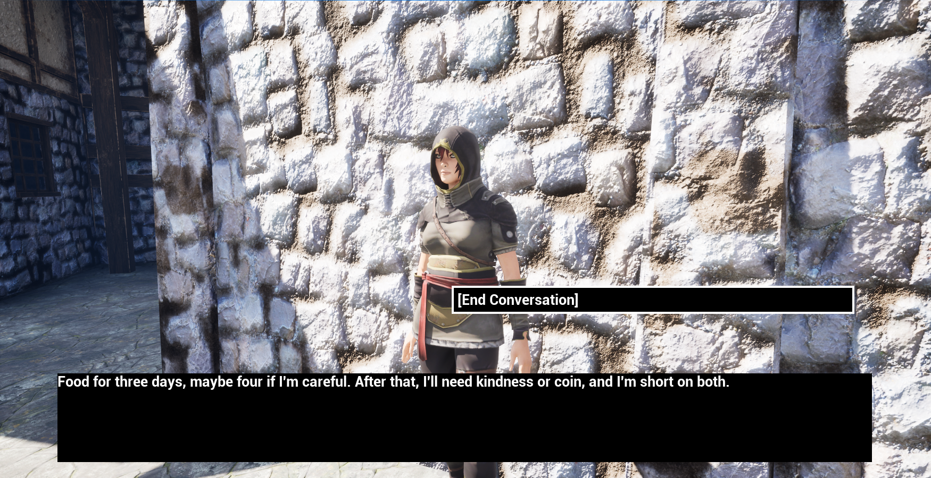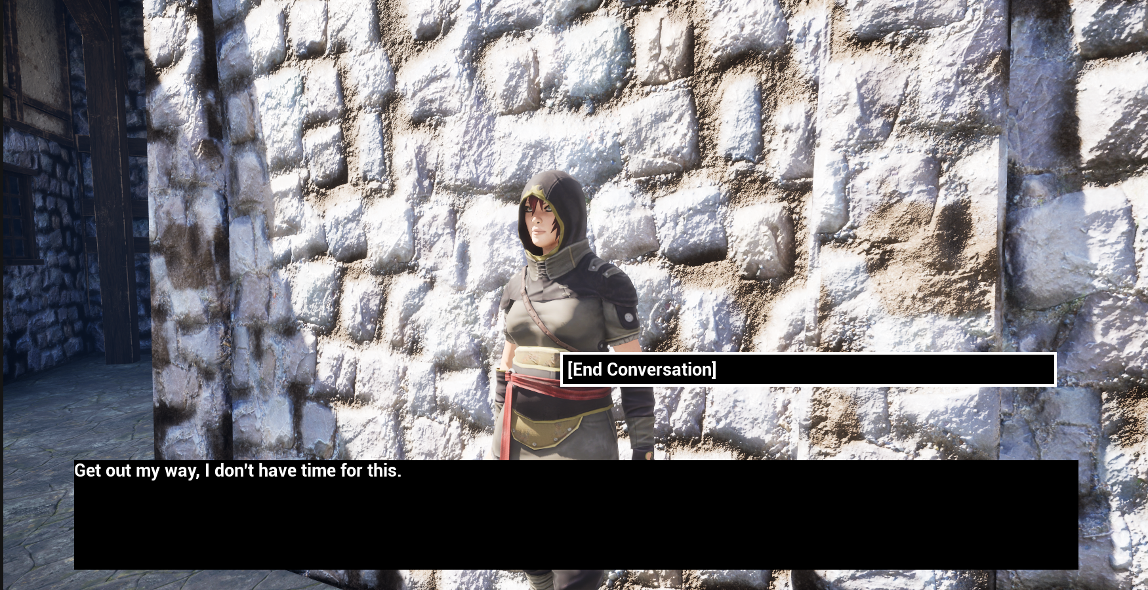
The villager outside the tavern will have multiple dialogue options that focus on her muttering to herself about leaving the village or telling the participant to leave her alone. This is designed to be a background NPC that the player in a game would be unlikely to talk to but still needs to contain some dialogue just in case they do. Keeping the dialogue simple with little relevance to the main quest means that while it’s not entirely useless to talk to her for some context the participants won’t lose anything from no conversing either. This conversation will have no player dialogue options.
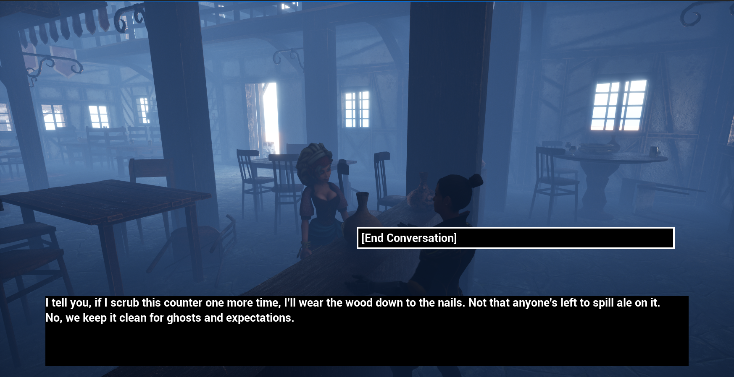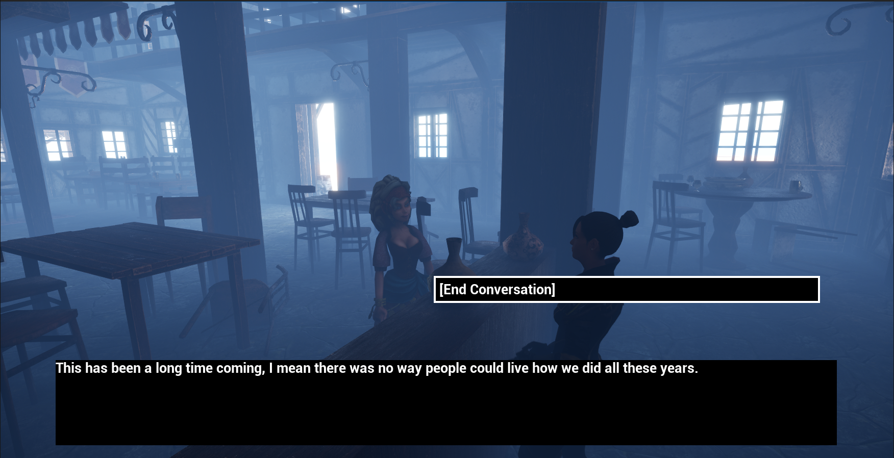
The conversation between the bar worker and village girl will act as a background conversation however this time more details about the story will be hidden within the dialogue. This will give players a reward for talking to them through extra context that can be obtained from the start without going through the whole quest. This conversation will also have no player dialogue options except for ending the conversation early. The dialogue will be between the two NPCs to simulate listening to an in-world conversation.
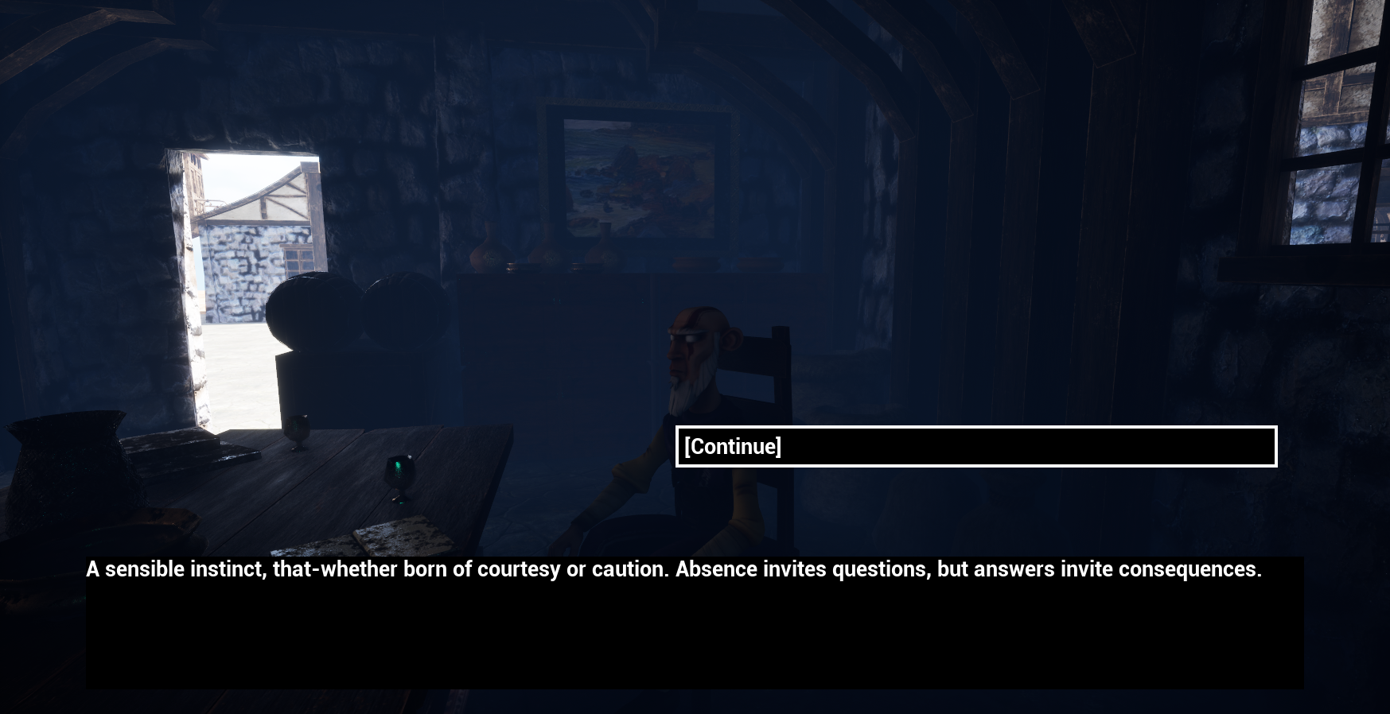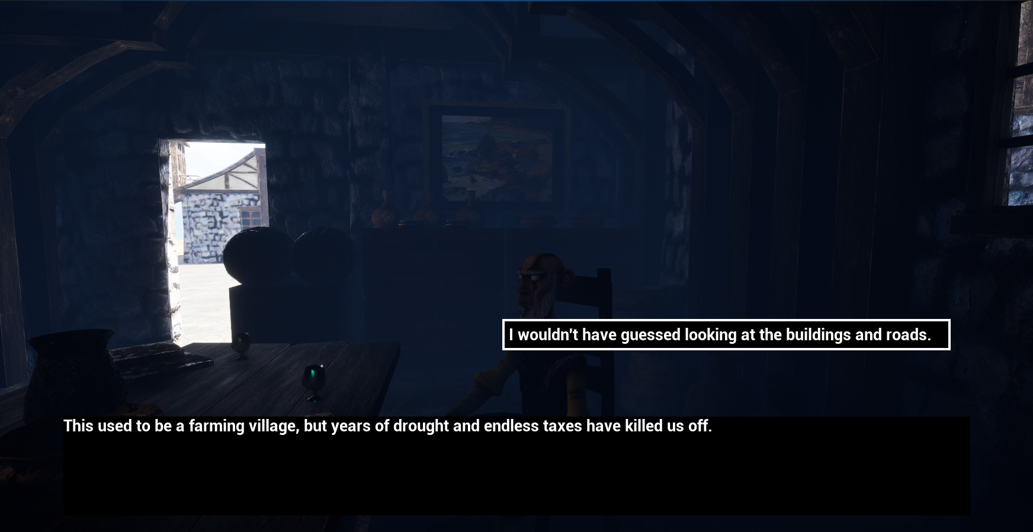
The quest will be split into three different conversations and the first will be with the Elder. This dialogue will focus on setting the scene for the story and sending the player to the next part which will be the knight. Information will be scarce and the participants will be reminded to complete the quest in order to get more information on the story (this also tells them what to do to advance the scenario). The dialogue with the knight will reveal some details but will be kept short as more of a stopping point to build anticipation. The final part to the story will be back at the Elder. This dialogue we reveal the whole story and hint at what the Elder plans to do next. This will work as the climax and ending to the story. The story is designed to leave room for interpretation as this will give a better test to the AI’s capabilities in story writing and if it will be able to conceal information till the end.
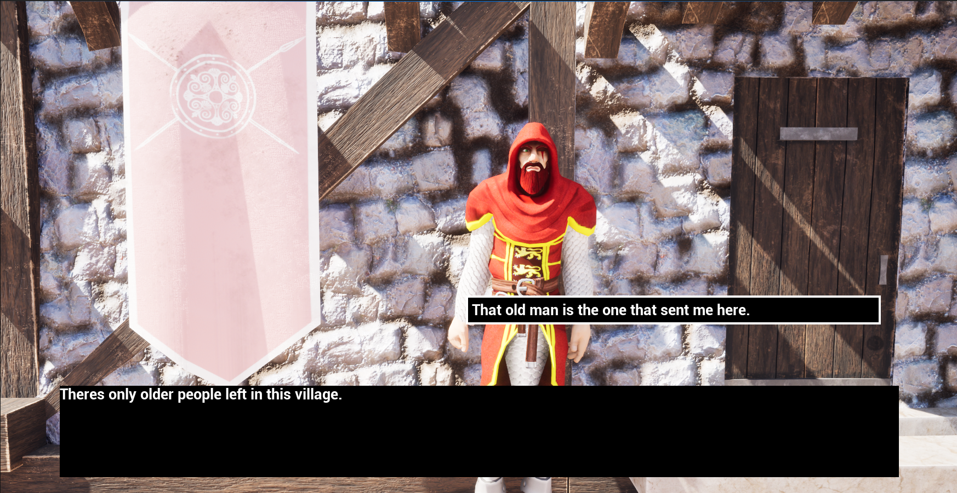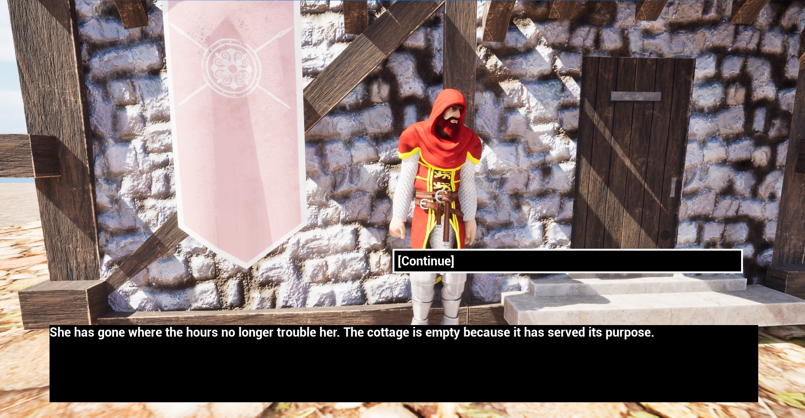
The goal for the user will be to talk to the villagers until they find the one that will give them a quest. Only select NPCs will have proper dialogue that the user can interact with the rest will have single lines that will either brush the user off or hint towards which one has the quest. The NPC with the quest will be the village chief and the user will need to converse with them to be able to receive the quest. The quest will be a simple retrieval quest where the user will go to a location talk to a person there and receive the item. Once the user brings that item back to the village chief the last bit of dialogue will play before the scenario ends.
  - Data
The information that will be gathered from this investigation will be focused on the participants opinions on each scenario. They will also be asked to comment on if the use of GAI is an issue to them as well as if they found any issues in general with either version. The goal here is to obtain data on people’s opinions to see which version was preferred so a conclusion can be formed on the advantages and disadvantages of using GAI to create dialogue.
The second part to the data will be to analyse how fast and effective it is to use GAI from the development side. For this the overall time it takes to produce all the dialogue for each version will be used as data. Notes on changes and difficulties when generating the AI version will also be used as data to give perspective on both the client side and development side of using GAI.
  - Investigation questions
Question 1. What was your overall opinion on the dialogue from the NPCs you interacted with, and did you see a difference between the two versions?
Question 2. Were there any unnatural elements to the dialogue or text that didn’t fit the conversations and/or environment?
Question 3. Which version had the most natural and thematic dialogue?
Question 4. Which version did you prefer?
Question 5. Which version do you think is the AI generated one?
Question 6. After learning that version 2 is AI generated does this change your opinion on which version you preferred?

Results and Findings
The investigation into the use of GAI in the development of games led to some interesting results that tended to contradict or at least oppose the general bias around AI and GAI. The testers were required to play through two simple scenarios where they would talk to two to five NPC’s and consume various conversations pertaining to the specific characters. The two main NPC’s that were required to speak to in order to complete each scenario told a brief story of the area and what had transpired previously. After completing the first scenario the tester would move onto the second immediately. After completing both scenarios, the testers were asked to fill out a form containing six questions relating to their thoughts on each scenario and which one they preferred. The next part will give an overview of each question and the average result that was given by the testers.
Participants opinions on dialogue for the NPCs was that the human version was more straight to the point and in some cases easier to follow, whereas the GAI version had more detail, but this made it harder to understand or follow.
The participants said that the Human version had no real feedback except for it not having any unnatural elements. The GAI version however had a couple of points that were picked up on. The first one was that it tended to waffle on more than what was necessary, it also had a constant reminder of time throughout the entire dialogue. It should be noted that this was not intended and, in the context, given only one reference to time was mentioned. The last point was the number of dashes thought the text was weird and out of place.
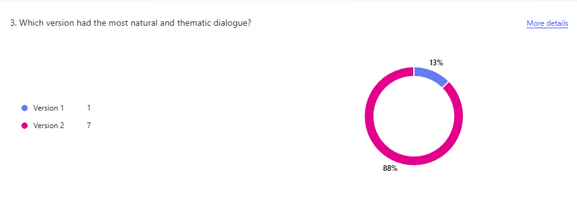
The participants said that the GAI version held the majority of the votes for the most thematic dialogue. A note from the participants was that the GAI version went into more detail on the theming over the human version.
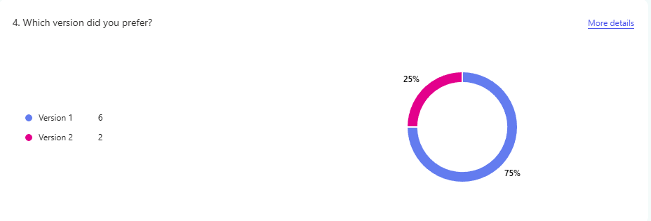
The participants preferred the human version over the GAI version as the GAI version seemed to “waffle” on and the participants lost interest at various points because of this. On the over hand the human version being far more to the point made it easier to sit through for this test.
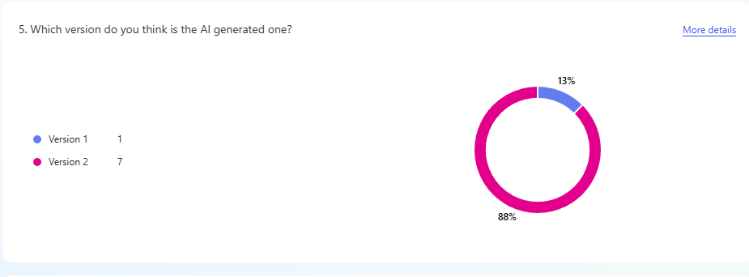
The participants were asked to identify which version was the AI generated one and 88% of the participants realised that version two was the GAI one and that version one was the human made one.
The participants said that version two being made using GAI did not impact their answer on which version they preferred. They went on to say that they don’t mind the use of GAI. Instead, one participant re-iterated that the issues lie with the GAI version being worse than the human version. Five of the participants just said “no” to it impacting the preferred version.
Parts of the dialogue needed to be cut out or changed due to it mentioning places that didn’t exist in the context of these scenarios such as stating that the current conversation with the elder was taking place in a square (open area inside a town or city usually in the centre) and not in the tavern where the player and elder actually are at this point in the scenario. Other lines were deleted for various reasons such as not fitting the conversation or environment as well as out right changing the story for no reason. As the story went on more and more lines needed to be removed as the AI seemed to lose its context while still remaining inside the stated context limit by OpenAI.
One last thing to note which was discovered during the final stages of production of the scenarios was that the ChatGPT made a contextual mistake. OpenAI claim that ChatGPT- 4 has a context limit of 128,000 tokens which is approximately 500,000 characters however in the scenario the context given states that the old lady, which is a character talked about in serval instances, is dead. In the second part of the GAI elder dialogue the elder says that the old lady was the first to leave the village implying that she is alive when in the dialogue before this the knight says she is dead.
During the development process a rough time was taken of how long it took to write the human version and generate the GAI version. The human version took around three to four hours. This includes the creation of the story, setting and what NPCs will have what dialogue. This was spanned across two days of work and anything done not relating directly to the dialogue writing was not counted towards the time taken. The GAI version took around seven to eight hours to generate spanned across three days. This includes the time taken to come up with and write the prompts for the responses and the initial context that needed to be provided. It also includes the time taken to check the responses, re-generate ones that didn’t work or fit the story and make any changes that needed to be made in order to create coherent dialogue.

Discussion and Analysis
Reference back to lit review and compare
The results of the investigation are interesting and show some peoples perspectives on the use of GAI in the development of video games however, the sample size is small which could mean that these results do not show the entire picture. With this in mind the results will be used to compare against the research and show the differences as well as showing the findings of using GAI to create dialogue and what benefits and disadvantages were seen.
  - Opinions on the use of GAI
The investigation has shown that the majority of participants that reviewed the scenarios preferred the human made dialogue over the one generated by AI (ChatGPT was the model used). While this cannot be used to say that the majority of people in general prefer human made content over AI some points can be ascertained from this data. One of these points is that in contrast to the research done the reason why people did not like AI wasn’t to do with it not being produced by a person. Instead, it had more to do with the quality of what was being produced. When asked if they would have played a game that uses GAI dialogue the common response was that they wouldn’t mind as long as the dialogue was good. This contradicts the results found from the research which stated that peoples bias surrounding AI and its capabilities is not favourable (Corden, 2025) (Chong & Yang, 2023). This brings about an interesting point because from the perspective of the participants the negative bias surrounding AI that others fall victim to doesn’t actually mean anything to them. In contrast they stated that they would prefer the use of AI in games if it improved the overall quality of the game. The point here is a normal human contradiction where it’s not that they don’t like AI it’s that they don’t like that AI is bad. If AI was better at generating higher quality outputs, then they would like AI but the core concept of AI itself is not the issue to them. While this is what they had stated themselves a point can be made to say that although they say they simple preferred the human version their subconscious bias towards AI might have had a larger influence on their answers. The only real information that has been acquired is that the participants said they don’t mind the use of AI but still chose the human one. They also knew which was the human version and which was the GAI version as they managed to work out which was which before answering the questions. On this point an argument could be made that the human version was by all accounts of higher quality however, while being only one of many factors to a story’s quality, most of the participants agreed that the GAI version was more thematic and suited the environment as well. This can’t be taken as opinion of the majority however at least a small percentage of people out there have this outlook on the subject of AI.
  - Issues with using GAI
One of the most interesting results was that the human version was actually the preferred version over the GAI one. One of the main advantages to using GAI to create dialogue was that it would be interesting and interactive (Gayathri, 2025). The human dialogue was written in order to convey the story of the scenario from the characters perspective. Whilst this sounds right the issue is that the writer does not have any real experience in writing stories or at least this kind of story, so the quality wasn’t of the highest degree. However, the majority of the participants still preferred the human version. This most likely has more to do with the fact that the GAI version whilst using books and other stories as sources for its examples. It picked up some writing quirks that put off the participants more than drawing them into the story. It decided to focus in on the concept of time heavily. The only reference to time that was given to it was that the elder of the village wanted the player to get a stopwatch for them. It must have thought this item was the centre piece of the whole story and decided to write around it. This in and of itself is not wrong as most stories are written with a single point of focus in order to keep the story on the same page the entire way through, however the issue came about from the number of references to time. In the quest time was mentioned 37 times either directly or alluded to in some way. So, from one word in the context the entire story was based around time. The reason it did this could be because it has found that focusing in on a specific point makes a better story and this was the best thing to focus on, but this is also one of the main points that people didn’t like about the GAI version even if it wasn’t made using AI.
An issue with the use of GAI was that it took twice as long to produce the GAI version of the dialogue compared to the human version. Multiple factors should be considered with this point. To start with the GAI version was around 700 words longer than the human version. Whilst this is the case one of the main complaints with the GAI version is that it “waffled” on too long and didn’t seem to make it to the point. This means that the extra length didn’t actually aid the GAI version making the extra time not worth it. For further information the extra time didn’t come from the generating of the dialogue but instead the time required to guide the AI into making the correct dialogue by writing very specific prompts for it. Part of this was due to trying to get a specific story without just having it re-write the human dialogue in its own way (this could be a worthwhile experiment to see if the AI can create a better version of the human dialogue). Even though this is the case most studios would want a story the at least came up with the concept of instead of letting the AI handle the theming and story boarding then creating a game around what the AI has made. Looking at the issues surrounding the GAI version it is safe to say that the human version was easier to create and had a better reception from the participants. This shows that using AI does not necessarily speed up the development process of creating games and that the quality isn’t up to the standards that some people look for when they play games.
The generation of dialogue using AI had some issues as well. Mainly with the need to remove parts, the parts removed ranged from single lines to entire sections or even needing to get ChatGPT to re-generated parts that didn’t work at all with the context of the story. The first part that was deleted was around halfway through the elders first part of dialogue. It had to be deleted because it made the stopwatch into the centre piece of the story. The dialogue already focused too much on time however that at least didn’t affect the story as much as changing the premiss to be focused on the stopwatch. This caused an issue where using GAI should have removed or at least decreased the amount of stagnation in the story as the research had suggested it would, however it instead added more stagnation. The next change was quite small; the word square was changed to tavern as the current conversation was taking place inside a tavern not in a town square. The only thing is that the AI was told that the conversation was being held inside the tavern. Even if it wasn’t adding a location to the dialogue is more detrimental as it would force developers to either change the dialogue as it was here or build the world around the dialogue that the AI wrote. The next mistake happened in the next dialogue. It mentioned kept fields that hadn’t been tilled however the fields in the scenario are tilled. This information wasn’t provided to the AI in the context, and it was also told to mention the farms, so this error was not its fault but nonetheless still required correcting. Half a response needed to be deleted as it felt to deep for the current conversation as the start of the quest was meant to leave the participants with questions and not feel emotional until the latter half. These next ones happened inside the knight’s dialogue. The first one had a recurring issue of focusing to much on the stopwatch that was not stated to be a centre piece of the story. The second one had the same issue but also ha a contextual problem. The stopwatch was made out to be kept for a while but by the end of this dialogue the knight will say that the only way to get the stopwatch is if it will be given to the elder. While this is only a small issue it still disrupts the flow of the story. The reason issues like this can occur is because the AI has no idea what it will make next and what the user will ask it to generate. Meaning it is incapable of seeing into the near future or at least having a rough idea of what’s to come. The rest of the issues occurred during the second part of the elder’s dialogue. The first issue here was a contextual problem where the elder asks if the knight is dead. This didn’t make sense because the elder states that he knows the knight is alive. On this point as well killing off a character would be a massive change to the story which would cause issues for developers. It didn’t actually state the knight is dead but as almost all of the dialogue is implied rather than stated asking a question like this may give the participants the wrong idea. The other issue with this part of the dialogue is something that had been manually taken out whenever the dialogue was generated but had been missed in this instance until it came to the implementation of the dialogue. That is notes inside brackets of the characters reactions and facial expressions. While not being an issue for stories especially those inside books it is less common for dialogue in games to use this writing style. There are games out there that do and it can add extra depth to the story however as this was not the writing style being used it was more of a time-consuming annoyance to take out. The next part was less of an issue and more of a note. The generated response was so long it had to be split into separate parts however the AI did cover all the necessary points so it was not given the command to re-generate the response while making it shorter although this option was considered. The last problem was that the dialogue did not portray the story correctly. This was in part because the prompt given was vague so the prompt was changed and the AI was asked to generate a new response in accordance with the new prompt. The final thing to note here is that the longer the dialogue went on for the more mistakes and errors were made. This has to do with the AI’s ability to remember context which should be everything up to 500,000 characters although due to some obvious continuity errors present the proof of this was not shown. This would cause issues and force developers to make considerable alterations for full length stories for their games.
The research shows that the goal for AI is to make them feel more human-like (Peñalvo & Ingelmo, 1970). Through the results of this project, I have found little evidence to prove that the current state of GAI has in fact achieved this human-like behaviour. One of the questions asked to the participants was which version of the dialogue did they believe was the one wrote by AI. Almost all of the participants answered correctly that version two was the GAI version. While the differences between the versions have been discussed at the end of the day the GAI failed to produce a story that was dissimilar to the human version meaning that it failed to make itself human in nature when writing this story. On the other hand, it could be argued that one does not need to be human in order to write a good story and it may in fact be better for developers if the AI forgoes the pursuit of human-like behaviour in order for it to function at a higher level. An alternate solution would be the creation of an AI that is purpose built to write stories specifically for games. This could then be improved upon in order to fulfil its purpose to the highest possible degree. This does still pose the same issue of current AI not being up to the task in comparison to a humans’ skill level however this could be a better option than waiting for other AI. This AI would be able to focus on this goal alone whereas other AI, take ChatGPT for instance are more generalised and could take longer to reach the same level.
  - Advantages of using GAI
On the other hand, while it did take twice as long to make dialogue for the main quest, which was the largest part of the dialogue that needed to be generated, it took almost no time whatsoever to make the dialogue for the other NPCs. This was aligned with what was shown from the research. That being that the use of GAI would increase productivity. It took at most 20 minutes to generate and write down the dialogue used for the bar conversation and the girl outside the tavern. In comparison it took around 2 to 3 times longer to write the human dialogue version for these characters. In effect it was the complete opposite to making the quest dialogue where it was longer to make the GAI version over the human version. This is partly because the dialogue didn’t need to say specific things or be as careful as the quest dialogue needed to be. On another note, the dialogue was still twice as long and could have been longer while still taking less time as all the time was used for writing the initial prompt for these conversations. After that was done a simple “generate more like these” was all that was needed. The only reason more dialogue wasn’t made for these conversations on the GAI version was because they were already long enough and being any longer wouldn’t have benefited it in any way. None of the participants mentioned or wrote any problems revolving around the dialogue unrelated to the main quest. This could have been because they weren’t paying as much if any attention to it or just because they didn’t find any real issues. With this it should also be noted that two of the participants skipped this dialogue entirely in both versions even though they were told about it existing. Areas of less importance in games can go unexplored by players but still need to be there for those that do always look at each area in its entirety however this means that developers must spend time on these areas. This could show a use for GAI in the development of games as it would take a fraction of the time in order for developers to make all these extra parts so that they could focus on the stories that matter more to game itself and to the majority of players. One of the biggest killers of releasing games is bringing the game out too early because the deadline was already set in place. Games like Cyberpunk 2077 and No Mans Sky have become record breaking titles that needed more time to be worked on before release in order to reach that point. Tools like AI could be used in order to speed up parts of development in order to help developers if used correctly.
  - Arguments against the validity of the investigation
An argument could be made saying that the GAI version was put at a disadvantage due to couple of reasons. The first being that ChatGPT had to replicate the same story that was used for the human version, in order to keep the scenarios from being rated on which story was more interesting, without being given the entire story to work with. Exceptions were made and certain changes, as long as they weren’t too extreme, were allowed to compensate for the issue. Even with these exceptions being made it does not change the fact that the GAI version only had base world context and a brief explanation of the way the story will proceed to go off when writing it. This could explain why time was chosen to be focused on when it had very little to do with the story in the first place. Without being told explicitly what to focus in on, because there wasn’t a specific point that needed to be referenced every sentence, the AI chose one by itself. What would have been a better option and what would have also seemed more human-like from the AI would have been if it had asked for a theme or topic to focus on. While this would be useful for developers it wouldn’t be necessary as it is up to the developers to state all the facts that they want the AI to use. On the other hand it would aid in the overall goal and development of AI as the purpose is to make more intelligent AI that feel more human-like (Peñalvo & Ingelmo, 1970).
Another disadvantage that could be argued would be due to the participants that were chosen for the project. Specifically, their willingness to participate compared to them actively wanting to take part in the project. While each participant openly stated that they would happily participate this was only after being asked. None signed up of their own volition without being prompted to in the first place. While this doesn’t seem like it would have any major effect on the outcome it could be said that at least subconsciously, they wanted to get their involvement over and done with as soon as possible. Meaning that whichever version was shorter would hold a slightly higher favour in their mind when it came to answering the questions afterwards. This could be seen as quite a stretch however multiple participants did mention that one of the reasons, they preferred version one over version two was because it was shorter and more to the point. This could mean that these people simply prefer stories in games to have less dialogue and be easier to follow. Maybe they prefer playing the character over reading about them. This could also explain why version one was the preferred version, which if this was the reason then it would change the meaning of the results gathered. It is impossible to make a game or story that everyone will like as all people have different opinions and preferences so the results could have been skewed by even small factors such as this.
The questions that the participants were asked to fill out after playing through both scenarios are also an area that could have been improved before completing the investigation. Specifically, the types of questions asked. Only having six questions had the advantage of making the participants feel more inclined to partake in the investigation however this also meant that less data could be acquired. Having more questions would allow for a deeper understanding of where the participants thoughts stemmed from which would give a clearer answer to the questions that the investigation tried to answer. The questions themselves could have also been changed to provide clearer results when answered. For instance, instead of question six asking if knowing that version two was made using GAI would change their opinion on which version they preferred. It might have achieved more useful results if it asked something along the lines of “is version two being made using AI one of the reasons behind your preferred choice.” This change would have opened the question up to more extensive answer instead of the typical “no” response that made up the majority of responses to that question.
The final argument that could have affected the outcome of the results is that version one was always played first. Originally it was intended for the version that went first to be completely random as this would give each version the fairest possible chance at being reviewed. The issue with a version always going first is that it could be said that the mistakes of the first version were forgotten about or buried by that of the second version. Another point could be that the second version was compared to the first version instead of the other way around. It could even be said that the participants had grown tired or bored, so they didn’t pay as much attention to the second version especially with its longer text. On the over hand it could be said that going first put the version one at the disadvantage as the participants may have forgotten about the it after experiencing the second version. The issue here is that in order to set up truly equal conditions for both scenarios the participants would have had to have done a random version on one day and the other version on another. However, even with this it could be said that the participants mood on each day could have affected the outcome in some way. In short in would have been nearly impossible to eliminate all the variables to set up equal conditions. The main reason that the scenarios weren’t at least randomised was to so that they could answer the questions with no influence from a third party telling them which one was which.

Conclusion
The purpose of this project and investigation was to discover the benefits and disadvantages of using GAI in a specific aspect of the development of games. The area chosen to be focused on was the creation of a story and other dialogue that could be used instead of human made dialogue. The hypothesis for this investigation was that the GAI dialogue would be of a higher quality compared to the human dialogue, would also be faster to produce and would be easier for the developers than creating the dialogue themselves. If this hypothesis was correct, it would give developers, the ability to speed up the development of games and save money in order to make game development more accessible. Even with this being the case the preferred version of dialogue used for the scenarios would be the human dialogue version, due to the current opinion and bias surrounding AI being negative. This means that the results would show that the human version would be the preferred version while the GAI version had less identified issues and was more thematic and truer to the world/environment.
While the hypothesis was correct and the human version was the preferred version, it wasn’t due to bias, at least from the answers given by the participants, instead it was due to the quality of the GAI version being lacking in comparison to the human version. Factors such as the overly long responses and insistent reiteration of time as well as the constant dashes in the text put participants off. Meaning that even if the GAI version was written to a higher quality than the human version in terms of actual text people couldn’t tell due to a weird writing style that the AI adopted. This also meant that most of the issues identified focused on the GAI version not the human version. The time it took to produce the GAI version was also considerably longer than that of the human version. It took over twice as long to produce the GAI version because of the amount of context needing to be written along with how specific the context needed to be so that the AI didn’t misinterpret it. This on top of needing to re-generate dialogue if it wasn’t up to standard made generating dialogue a long-winded process. Even with these measures being taken the AI still missed the intent behind the story that was given in the context and needed further prompting in order to get a story that resembled the desired one.
In the end the investigation did achieve its objectives however the results opposed the hypothesis in a few key areas. Those being: time taken, quality of writing and ease of use. This means that it takes too much time to produce the GAI dialogue considering development deadlines are already tight as is. The quality that is produced is not up to the standard that people want and it does not provide an easier alternative for developers to use. With all this in mind the conclusion that was been brought forth by this investigation is that the current state of AI has far more disadvantages that outweigh the advantages it can currently provide.

Recommendations
After the results were gathered from the investigation into the use of GAI in the development of games. The results gathered contradicted the research done into this area beforehand. This causes an issue in recommending anything using only one investigation. With this being the case there are still some recommendations that can be made from using both the results of the investigation and information gathered from research.
The first recommendation is to not use GAI in the final product of a game. The reason for this recommendation is because even with the contradiction found during the investigation the negative bias surrounding AI in general is far too extreme. Even larger triple A studios have seen intense negative backlash and drops in player count from simple rumours about using AI.
The second recommendation is if using GAI is a feature of a game such as with MIR5 and their adaptive boss fight (WEMIX PLAY, 2025). Make sure to allocate extra time towards this area of development as the investigation has shown that it can take far longer to create something using GAI than what is led to believe.
The final recommendation is to consider either standing clear of the AI bubble for the time being or planning and investing for the future. This is due to too much negative bias and the sheer lack of results shown for the capability of the current version of AI. After all in the investigation issues such as context being forgotten appeared on more than one occasion even though the context limit was nowhere near being reached. The future of AI could be what developers are looking for and if that turns out to be true then this topic could be revisited with an updated version and fresh outlook. Currently however the investigation and research did not show results capable of a positive recommendation towards its current use.

References
Artificial Intelligence in video games (2025) Wikipedia. Available at: https://en.wikipedia.org/wiki/Artificial_intelligence_in_video_games (Accessed: 27 October 2025).
Asaro, G. (2023) Understanding the addictive nature of League of Legends, LoLTheory Blog. Available at: https://blog.loltheory.gg/why-is-league-of-legends-so-addicting/ (Accessed: 09 November 2025).
Batty, M. (2025) Http://journals.sagepub.com/doi/abs/10.1177/0887302x07303626 | request PDF, Sage Journals. Available at: https://www.researchgate.net/publication/328039672_httpjournalssagepubcomdoiabs1011770887302X07303626 (Accessed: 25 October 2025).
Burnes, A., Paul, J. and Schneider, S. (2025) Nvidia redefines game AI with Ace Autonomous Game characters, NVIDIA. Available at: https://www.nvidia.com/en-us/geforce/news/nvidia-ace-autonomous-ai-companions-pubg-naraka-bladepoint/ (Accessed: 05 January 2026).
Campbell, M. (2025) Nvidia plans heavy cuts to GPU supply in early 2026 - OC3D. Available at: https://overclock3d.net/news/gpu-displays/nvidia-plans-heavy-cuts-to-gpu-supply-in-early-2026/ (Accessed: 09 January 2026).
Cazzamatta, R. and Sarısakaloğlu , A. (2025) AI-Generated Misinformation: A Case Study on Emerging Trends in Fact-Checking Practices Across Brazil, Germany, and the United Kingdom, Sage Journals. Available at: https://journals.sagepub.com/doi/10.1177/27523543251344971 (Accessed: 09 January 2026).
Chong, L. and Yang, M. (2023) Ai vs. human: The public’s perceptions of the design abilities of Artificial Intelligence: Proceedings of the design society, Cambridge Core. Available at: https://www.cambridge.org/core/journals/proceedings-of-the-design-society/article/ai-vs-human-the-publics-perceptions-of-the-design-abilities-of-artificial-intelligence/40E8A6DE075D5EBCC164EDE9EB707288 (Accessed: 04 January 2026).
Corden, J. (2025) Epic CEO: ‘Ram Price increases will be a real problem’ - as openai et al. blow up ram prices, threatening affordability of everything from Xbox to TVS and Laptops, Windows Central. Available at: https://www.windowscentral.com/gaming/epic-games-ceo-ram-price-increases-will-be-a-real-problem-for-high-end-gaming (Accessed: 07 February 2026).
Demirkol, O. (2025) League of Legends Player count, VALORANT News. Available at: https://www.thespike.gg/league-of-legends/beginner-guides/league-of-legends-player-count (Accessed: 09 November 2025).
Dhamani, N., Engler, M. and Massachi, S. (2024) Introduction to generative AI. Shelter Island, NY: Manning Publications.
Duarte, F. (2025) Number of CHATGPT users (November 2025), Exploding Topics. Available at: https://explodingtopics.com/blog/chatgpt-users (Accessed: 17 November 2025).
Feuerriegel, S. et al. (2023) Generative AI - Business & Information Systems Engineering, SpringerLink. Available at: https://link.springer.com/article/10.1007/s12599-023-00834-7 (Accessed: 25 October 2025).
Freeman, J. (2025) Student generative AI survey 2025, HEPI. Available at: https://www.hepi.ac.uk/reports/student-generative-ai-survey-2025/ (Accessed: 17 November 2025).
Gayathri, N. (2025) Generative AI: Disruptive Technologies for Innovative Applications. Hoboken, NJ, Beverly, MA: John Wiley & Sons, Inc. ; Scrivener Publishing LLC.
Howarth, J. (2025) 44 New Artificial Intelligence Statistics (Oct 2025), Exploding Topics. Available at: https://explodingtopics.com/blog/ai-statistics (Accessed: 23 November 2025).
How many English dialects are there in the world - learn languages with italki (2025) italki. Available at: https://www.italki.com/en/blog/english-dialects (Accessed: 10 January 2026).
IntegrationGlue (2026) What is the maximum context length that CHATGPT can handled?, Help Center. Available at: https://support.integrationglue.com/context-length (Accessed: 07 January 2026).
Jahani, R. (2023) Procedural elements in Marvel’s spiderman, Medium. Available at: https://medium.com/@jahani.rana/procedural-elements-in-marvels-spiderman-2885ce2b387d (Accessed: 27 October 2025).
Kaur, T. (2025) The hollow knight: Silksong DEVS were right to disappear for six years, TheGamer. Available at: https://www.thegamer.com/hollow-knight-silksong-team-cherry-right-to-disappear-six-years/ (Accessed: 08 January 2026).
Lambe, I. (2025) The surprising number of steam games that use genai, Totally Human Media. Available at: https://www.totallyhuman.io/blog/the-surprising-number-of-steam-games-that-use-genai (Accessed: 23 November 2025).
Langreo, L. (2024) U.S. students’ Computer Literacy Performance Drops, Education Week. Available at: https://www.edweek.org/technology/u-s-students-computer-literacy-performance-drops/2024/12 (Accessed: 04 January 2026).
Li, J. et al. (2016) Arxiv. Available at: https://arxiv.org/pdf/1606.01541.pdf (Accessed: 31 October 2025).
Malla Osman, Z. et al. (2016) Monitoring player attention: A non-invasive measurement method applied to serious games, Science Direct. Available at: https://www.sciencedirect.com/science/article/abs/pii/S1875952115000129 (Accessed: 09 November 2025).
Mantella - bring npcs to life with AI at Skyrim special edition nexus - mods and community (2023) Nexus Mods. Available at: https://www.nexusmods.com/skyrimspecialedition/mods/98631?tab=files (Accessed: 27 October 2025).
Martínez-Plumed, F. et al. (2019) Item response theory in AI: Analysing machine learning classifiers at the instance level, Science Direct. Available at: https://www.sciencedirect.com/science/article/pii/S0004370219300220 (Accessed: 31 October 2025).
Naeem, S. et al. (2023) An Unsupervised Machine Learning Algorithms: Comprehensive Review. Available at: https://www.researchgate.net/profile/Aqib-Ali-6/publication/368983958_An_Unsupervised_Machine_Learning_Algorithms_Comprehensive_Review/links/643c783f1b8d044c632ba4ab/An-Unsupervised-Machine-Learning-Algorithms-Comprehensive-Review.pdf (Accessed: 10 January 2026).
OpenAI and Nvidia announce strategic partnership to deploy 10 gigawatts of Nvidia Systems (2026) NVIDIA Newsroom. Available at: https://nvidianews.nvidia.com/news/openai-and-nvidia-announce-strategic-partnership-to-deploy-10gw-of-nvidia-systems (Accessed: 07 February 2026).
Partridge, J. (2025) The history of Minecraft, Red Bull. Available at: https://www.redbull.com/int-en/history-of-minecraft (Accessed: 03 November 2025).
Peñalvo, F.J.G. and Ingelmo, A.V. (1970) What do we mean by Genai? A systematic mapping of the evolution, trends, and techniques involved in Generative AI, Dialnet. Available at: https://dialnet.unirioja.es/servlet/articulo?codigo=9904595 (Accessed: 25 October 2025).
Rathod, V. (2025) Chatgpt API pricing & token explained simply (2025 guide), ChatGPT API Pricing & Token Explained Simply (2025 Guide). Available at: https://www.binstellar.com/blog/what-is-a-token-and-how-is-chatgpt-api-pricing-calculated-explained-in-simple-words/ (Accessed: 08 January 2026).
Riot Games (no date) League of legends homepage, League of Legends Homepage. Available at: https://www.leagueoflegends.com/en-us/ (Accessed: 03 November 2025).
Sandmann, L. (2024) Know the timeline of wow release date and how to keep updated, Exit Lag. Available at: https://www.exitlag.com/blog/wow-release-date/ (Accessed: 03 November 2025).
Sadeghpour, M., Arakala, A. and Rao, A. (2025) Generative AI in collaborative academic report writing: Advantages, disadvantages, and ethical considerations, arXiv.org. Available at: https://arxiv.org/abs/2504.08832 (Accessed: 17 November 2025).
Sutskever, I., Vinyals, O. and V. Le, Q. (2014) Sequence to sequence learning with neural networks | proceedings of the 28th International Conference on Neural Information Processing Systems - volume 2, ACM Digital Library. Available at: https://dl.acm.org/doi/10.5555/2969033.2969173 (Accessed: 31 October 2025).
Thomas, I. (2023) A dialogue pipeline. keeping your lines in line… | by Ian Thomas | Medium. Available at: https://wildwinter.medium.com/a-dialogue-pipeline-db0be8d8509c (Accessed: 05 January 2026).
WEMIX PLAY (2025) Wemix Play: Wemix play’s post, WEMIX_PLAY. Available at: https://wemixplay.com/post/33559 (Accessed: 05 January 2026).
West, D. M. (2018). The Future of Work: Robots, AI, and Automation. Washington, DC: Brookings Institution Press.
Zalace, J. (2024) How many side quests are in cyberpunk 2077?, TheGamer. Available at: https://www.thegamer.com/cyberpunk-2077-how-many-side-quests-jobs/ (Accessed: 07 January 2026).
[x]cube LABS (2024) Generative AI in gaming: Creating dynamic and adaptive environments, [x]cube LABS. Available at: https://www.xcubelabs.com/blog/generative-ai-in-game-development-creating-dynamic-and-adaptive-environments/ (Accessed: 09 January 2026).

Appendices

Appendix 1 – Human Dialogue
Human Dialogue.docx

Appendix 1 – GAI Dialogue
GAI Dialogue.docx

Appendix 1 – Raw Dialogue and Prompts
Raw GAI dialogue and prompts.docx

